FACEBOOK

First we will create two variables to store user’s email and password

Then we will open facebook.com on a browser

Then we will sign-in by clicking login button-

* search u_0_b by id

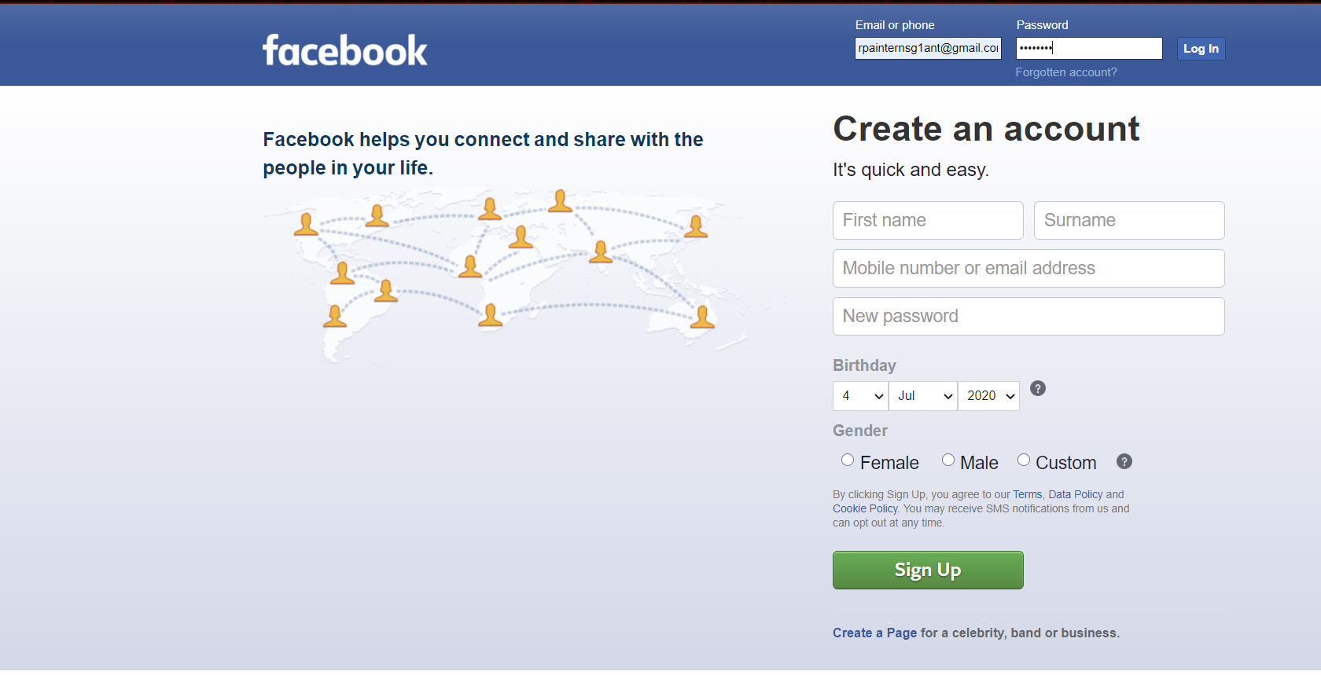

* We can create post by typing using xhpc_message by name and then clicking Post button using _45wg _69yt by class

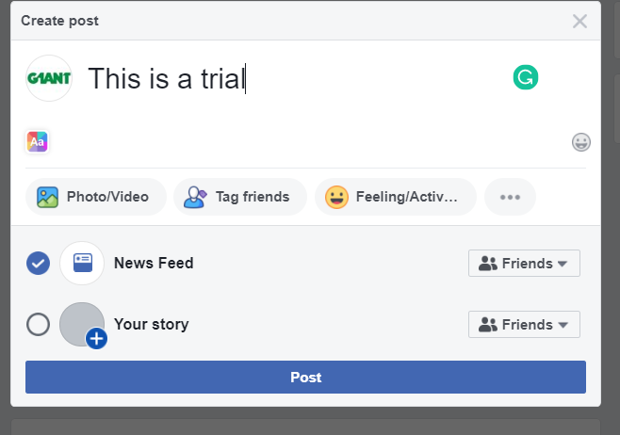

* We can find friends by typing in search bar using search q by name and then Enter it and then by identifying it user can send friend’s request to it.

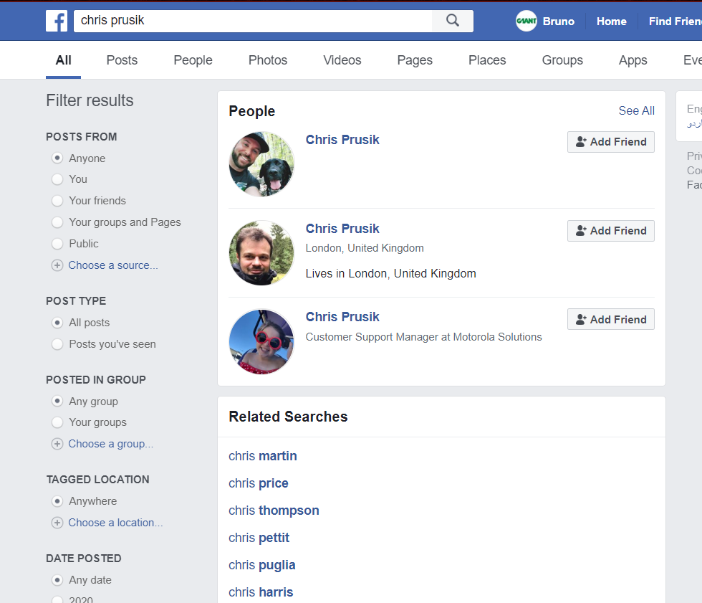

* We can like the latest post on our Newsfeed using _8c74 by class.

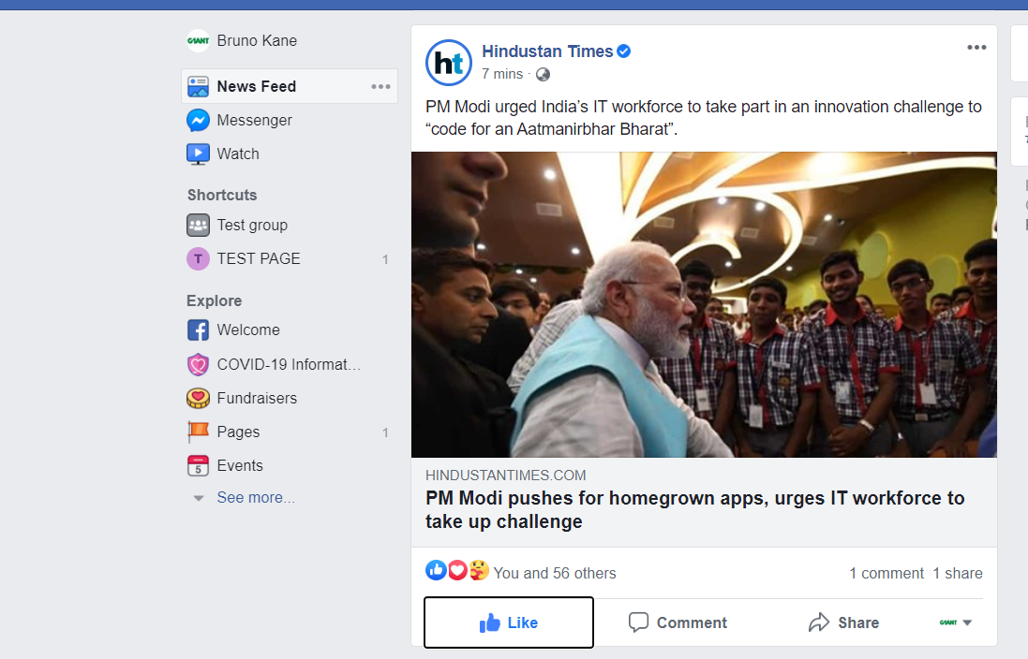

* We can create a group/page with a desired name using creation_hub_entrypoint by id and then click option of group or post using their classes

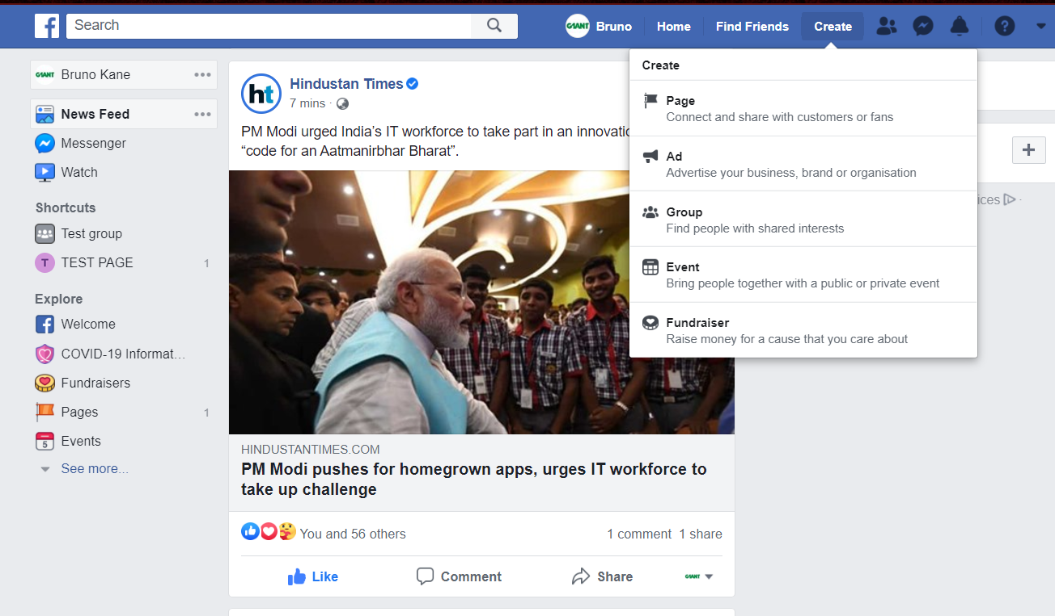

* And can select its privacy and then create it

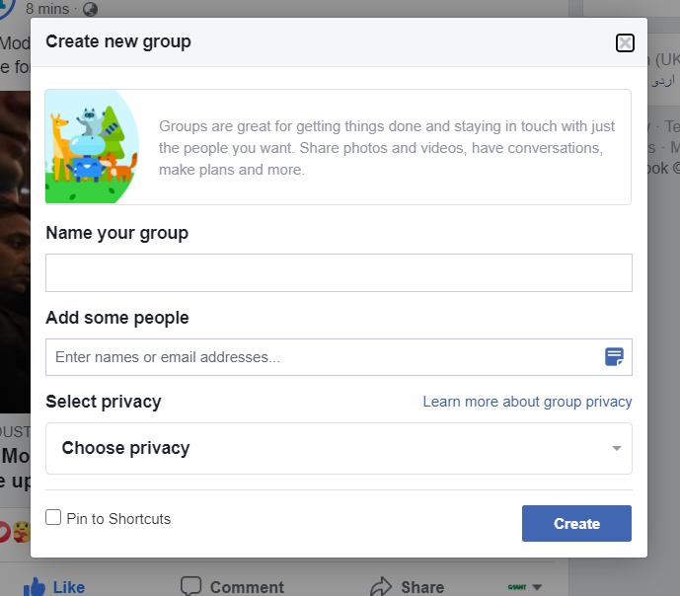

* We can retrieve no of posts from our newsfeed and display its content along with its time and name of uploader in a Dialog Box
* We can display no and name of friends the user have.

LinkedIn

* First we will create two variables to store user’s email and password
* Then we will open linkedin.com on a browser
* Then we will click sign-in button and sign-in by clicking login button

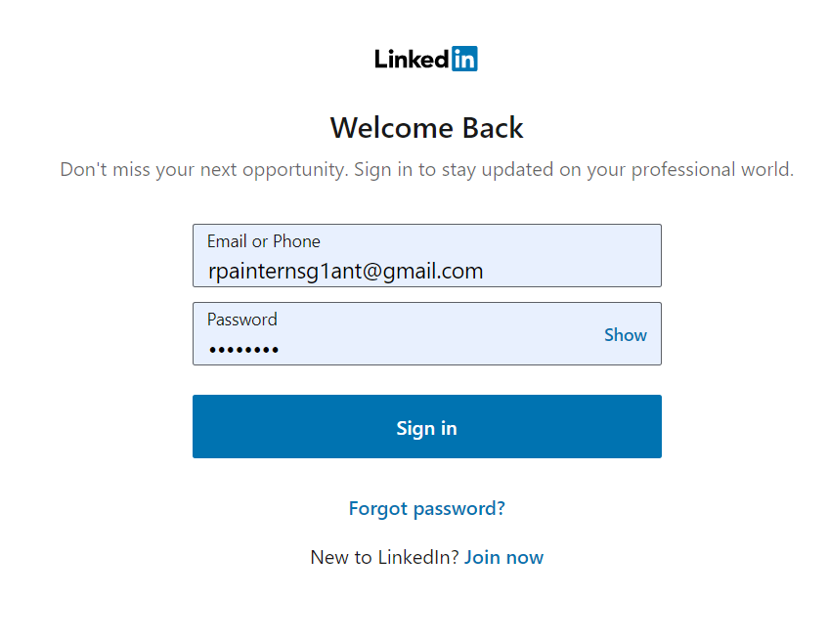

* We can find the people/company and we can open them and follow them on linkedin by taking input from user

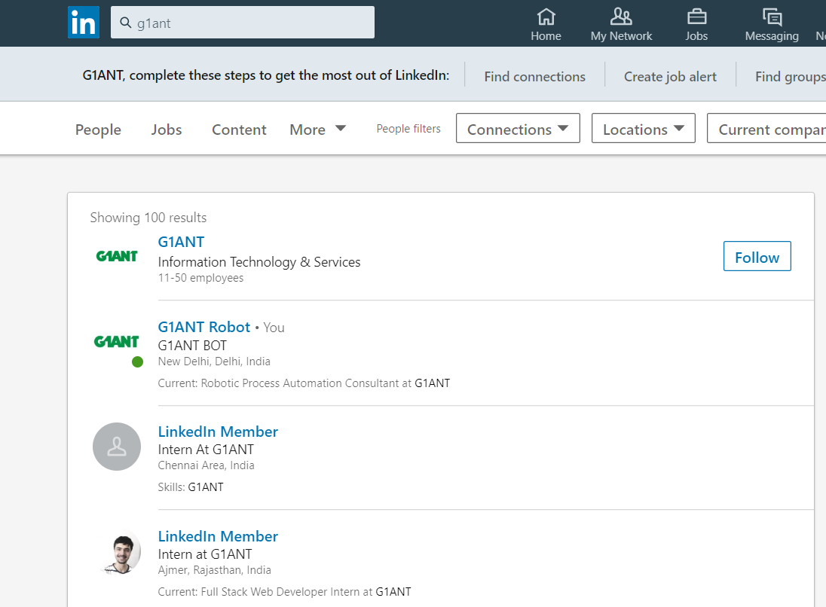

* We can write a post in linkedin by taking a string input from user and share it in the network

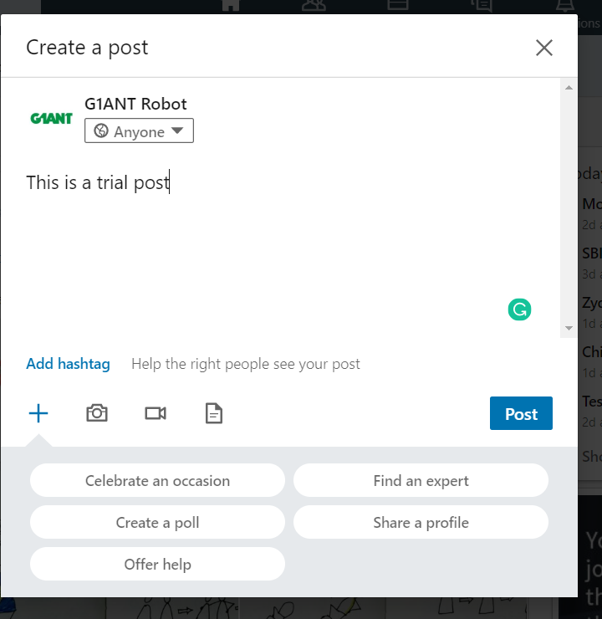

* We can take choice from user to like or comment on the latest post in its feed.



* We can display no of connections user have in a dialog box
* We can display no of people who have viewed their profile
* We can share the latest post of feed if the user allows

Youtube

* We can sign in the user in youtube.com by taking input from user for its login and password

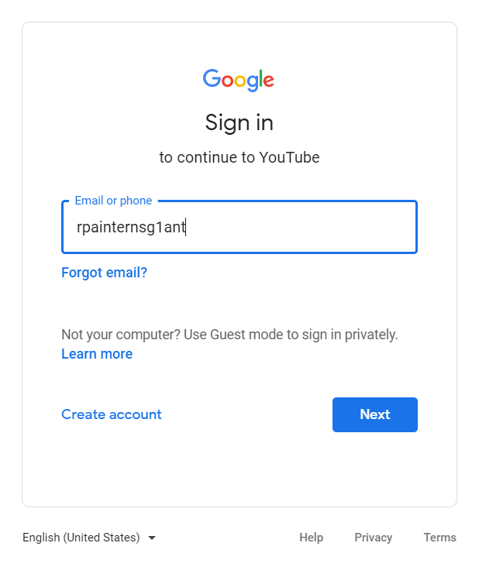

* We can take name of video as input and search it in search bar and then play the result on top of search result

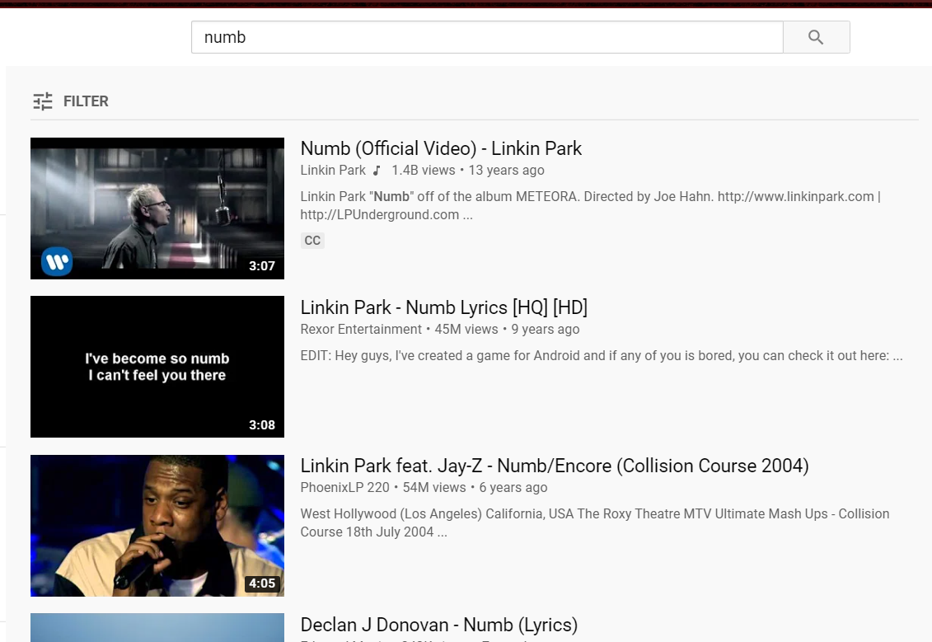

* We can like the playing video if user allows



* We can subscribe the channel which user will give input

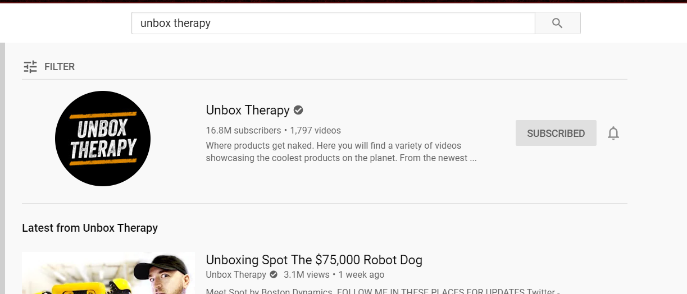

* We can comment in the playing video by taking user’s allowance and input for comment from user

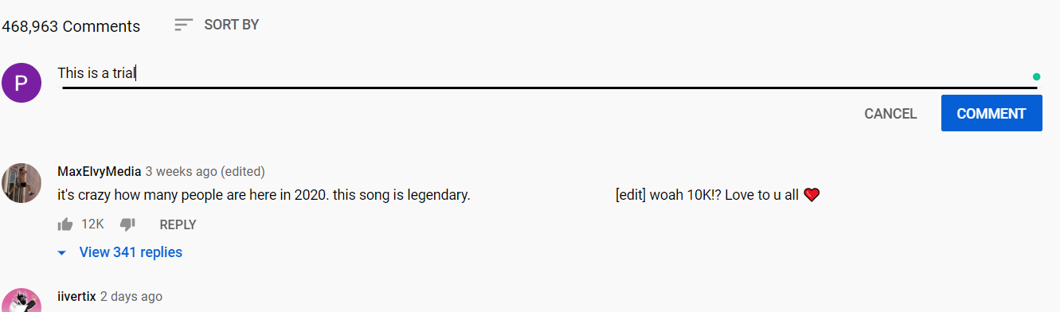

* We can create a channel and upload a video in it
* We can play the latest video of the user’s subscribed channel

Quora

* We can sign in quora.com by taking credentials from user
* We can put up a question by taking question as input from user

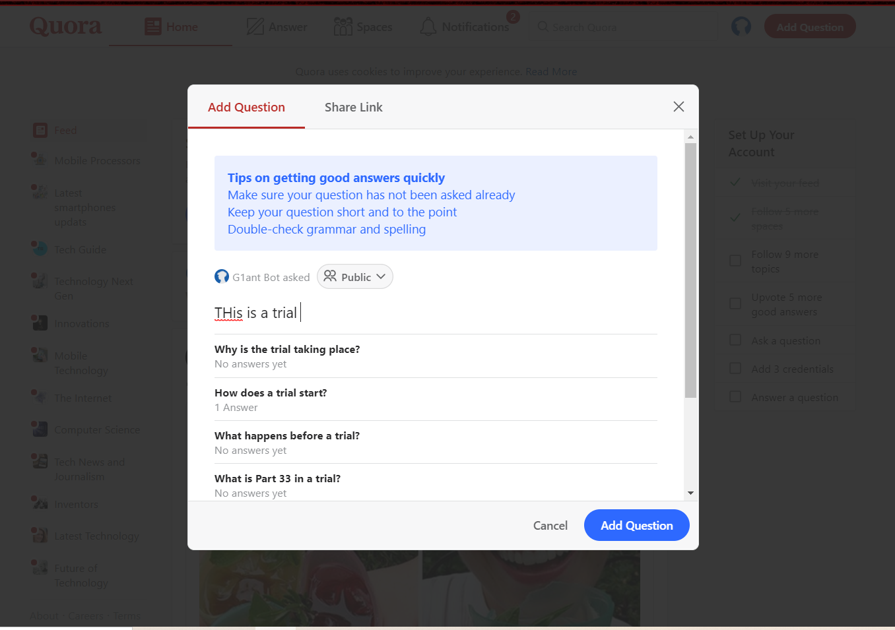

* We can search for question or any space in search bar

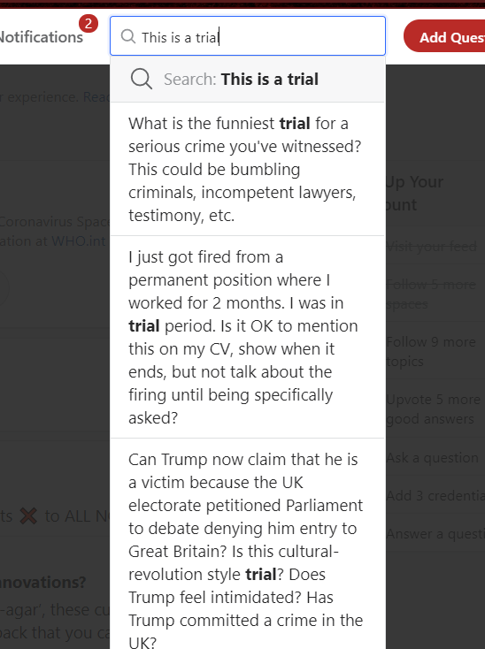

* We can see all spaces we are following

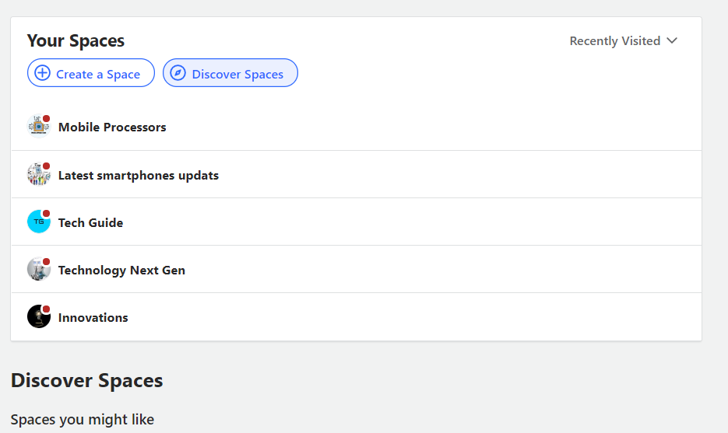

* We can see all notifications of the user

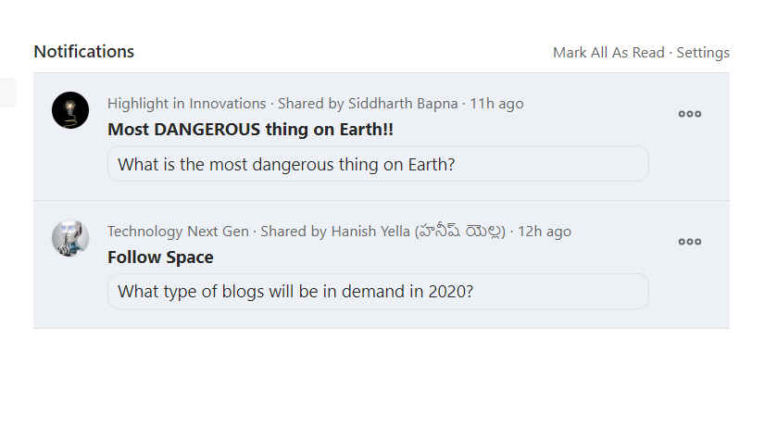

IRCTC

* We can open irctc.com website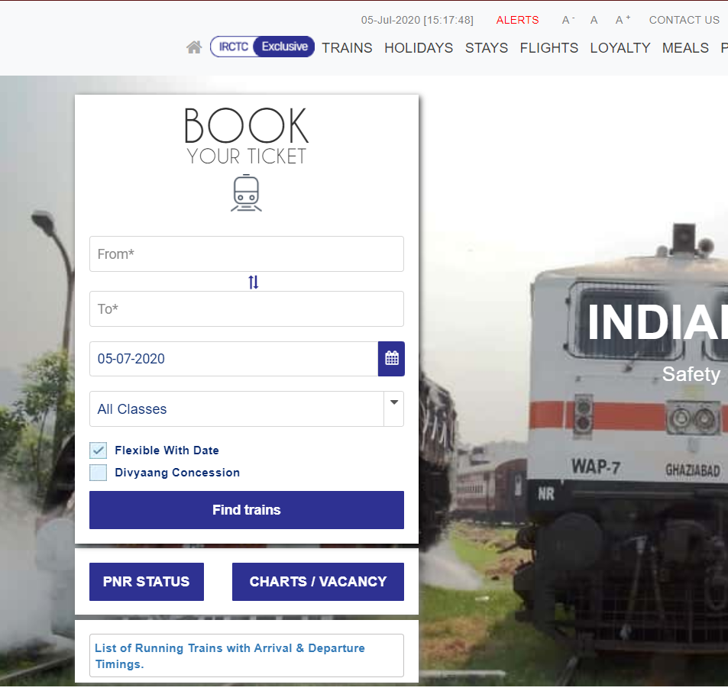
* We can enter origin and destination location by taking input from user

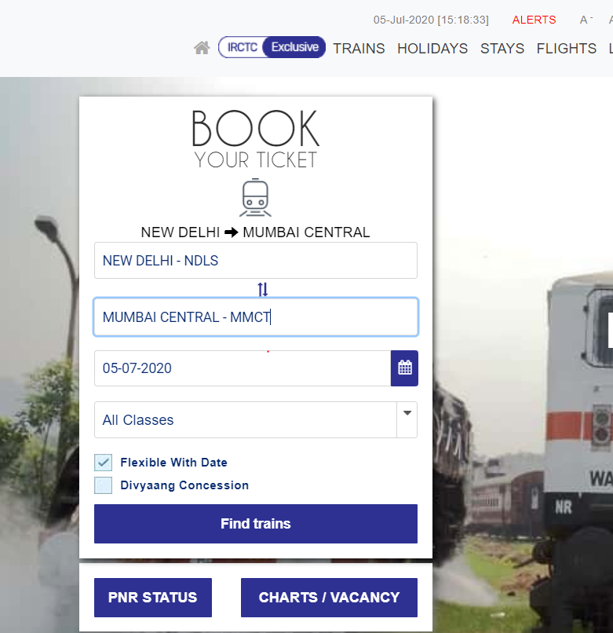

* Also user can enter Date of Travelling and can find trains on that date. Then user can decide which train is suitable for him/her.

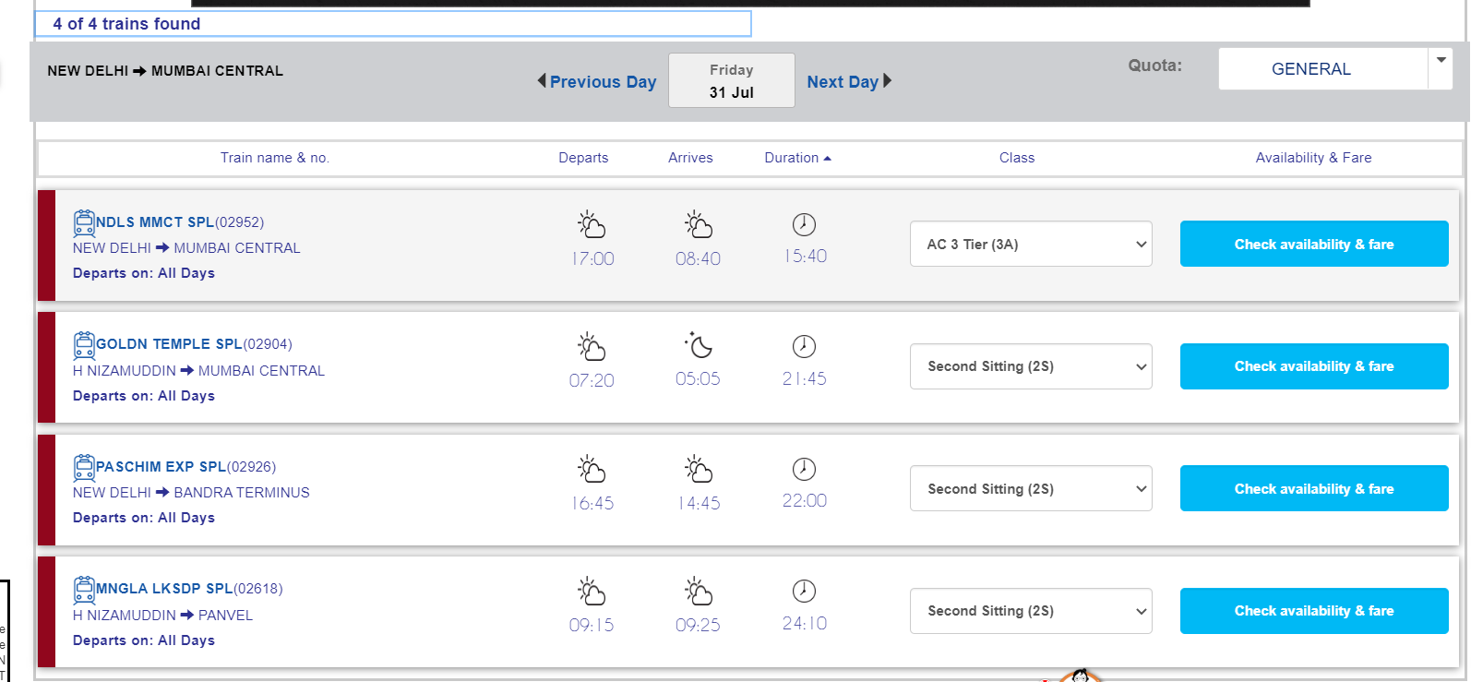

Microsoft Teams

* We can do user sign-in in its website

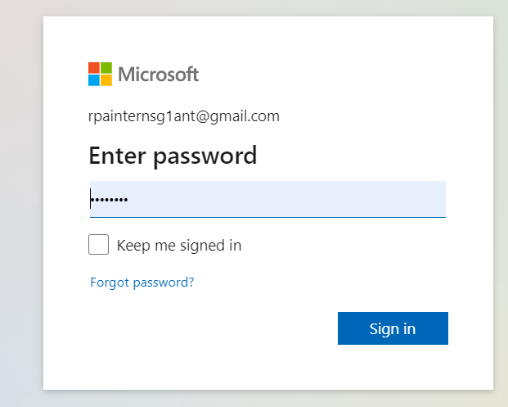

* We can create a team and name it also

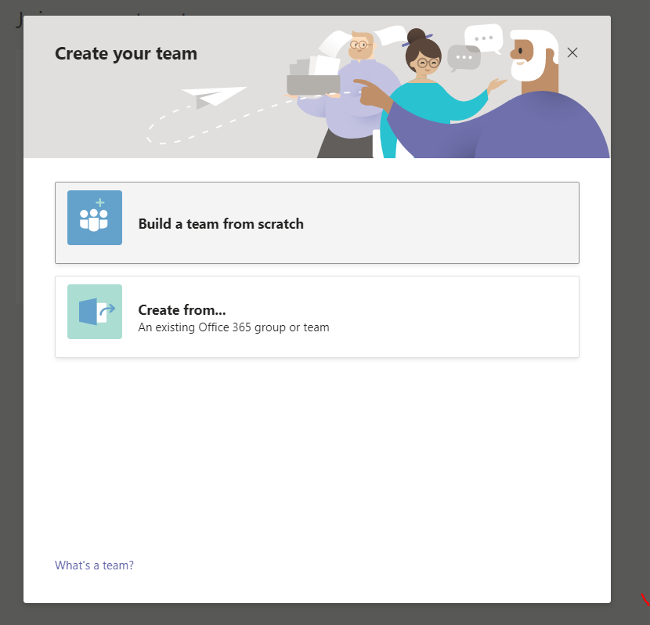

* We can do to chat with a person by taking user’s inputs

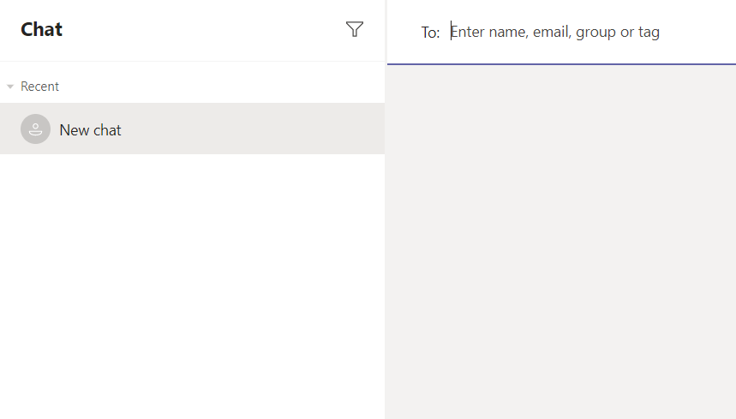

* We can add members in our team

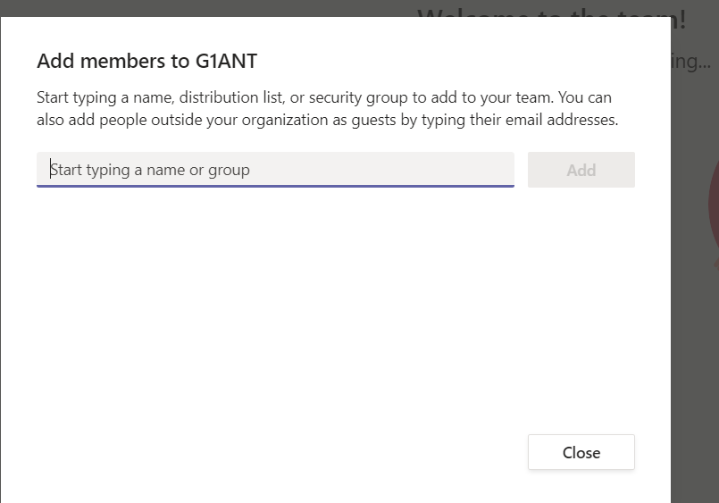

* We can call a person

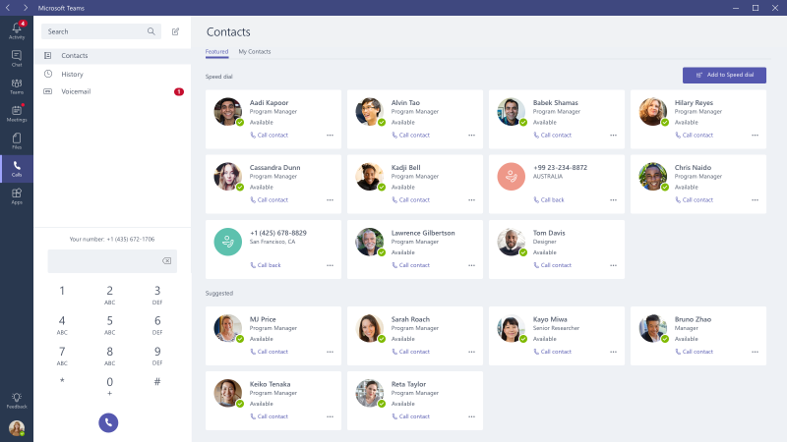

* We can schedule a meeting

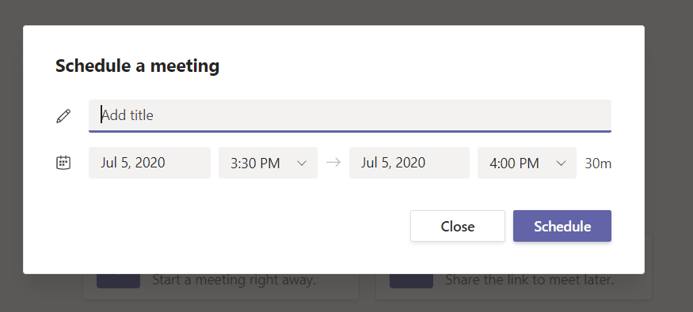

* We can see our activities

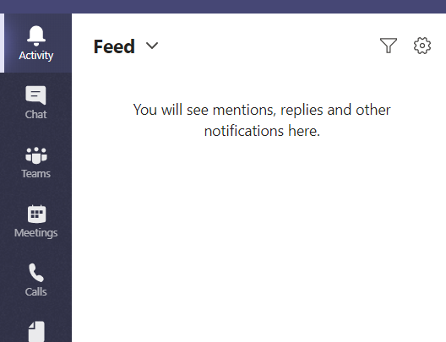

SWIGGY

* We can enter the location and find restaurant in it

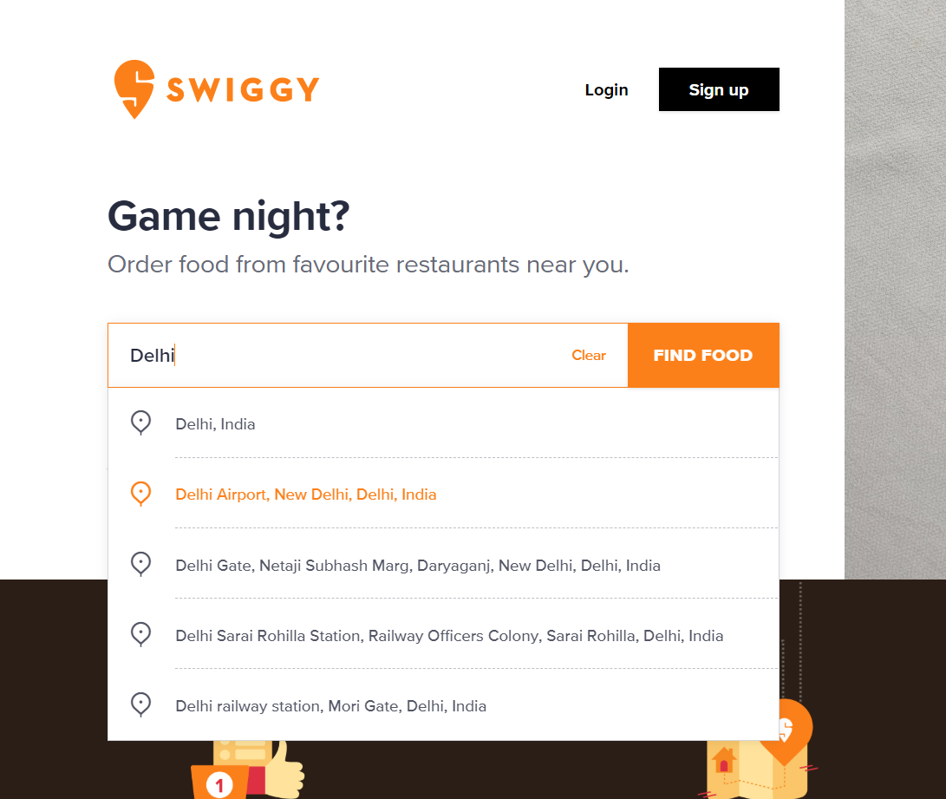

* We can take option from user that it wants pure veg

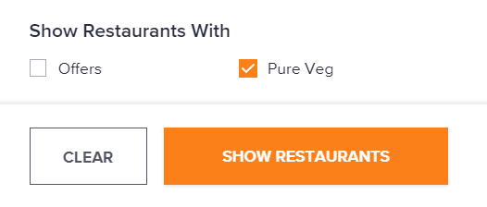

* We can sort the list of restaurants according to Relevance, Cost of Two, Delivery Time, Rating

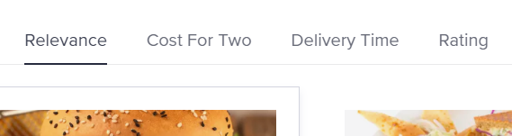

* We can then open the first restarant after taking user’s preference

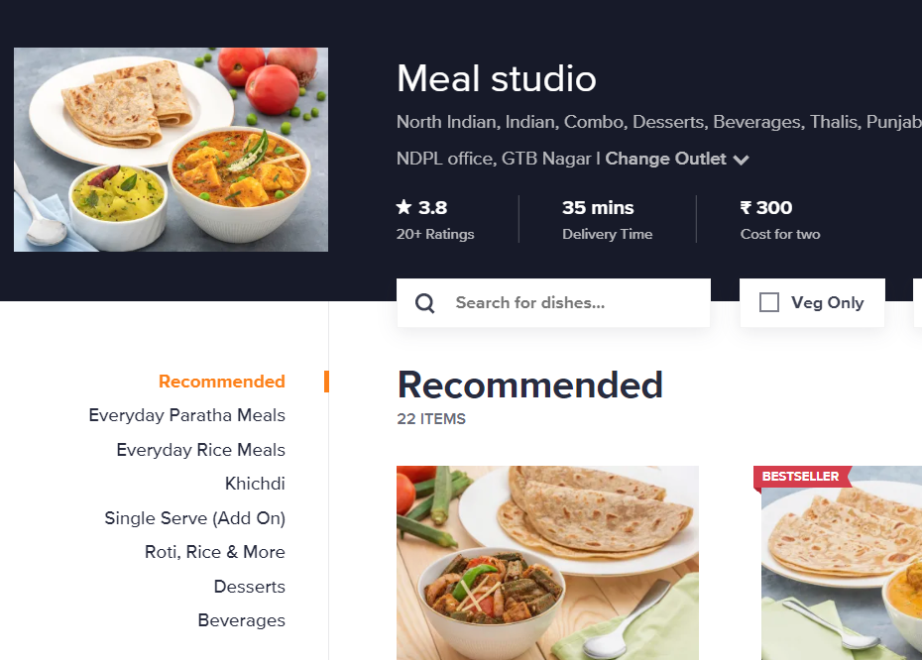

Amazon

* We can sign-in by taking user’s credentials

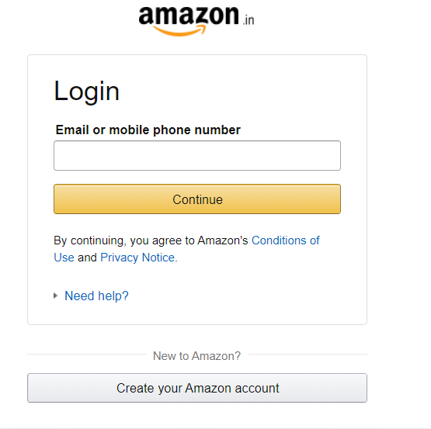

* We can search for item which we will take input from user

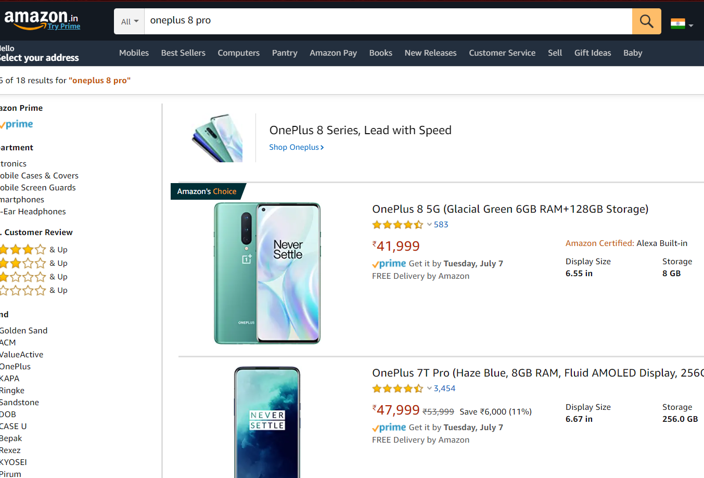

* We can sort them by given features

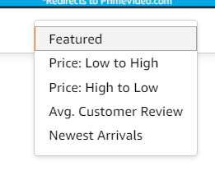

* We can open first product which is satisfied by user’s input

